Introduction to ITEZZE –
ITEZZE (Pronounced I-Tezzz) is an energy group supplying a swap and go style battery swap system for electric vehicles (EVs) cars, trucks and buses etc. using a system where vehicles have a fixed built-in (or ‘resident’) battery supplied by the car manufacturer and a slot to take a swap battery from the ITEZZE swap Network.

World oil output will be down by 10-15 million barrels per day (bpd) by 2022/23 (See: Oil reports); Oil is fundamental to society, so replacing it with ITEZZE – is fundamental to every investment in the country. The av. Australian car uses 60 litres/week, the av. family has 1.7 cars, if fuel prices rise by $1/litre – av. disposable income falls by $100/week.

ITEZZE is viewed as the world’s only scalable electric vehicle system. Other systems don’t work because of -
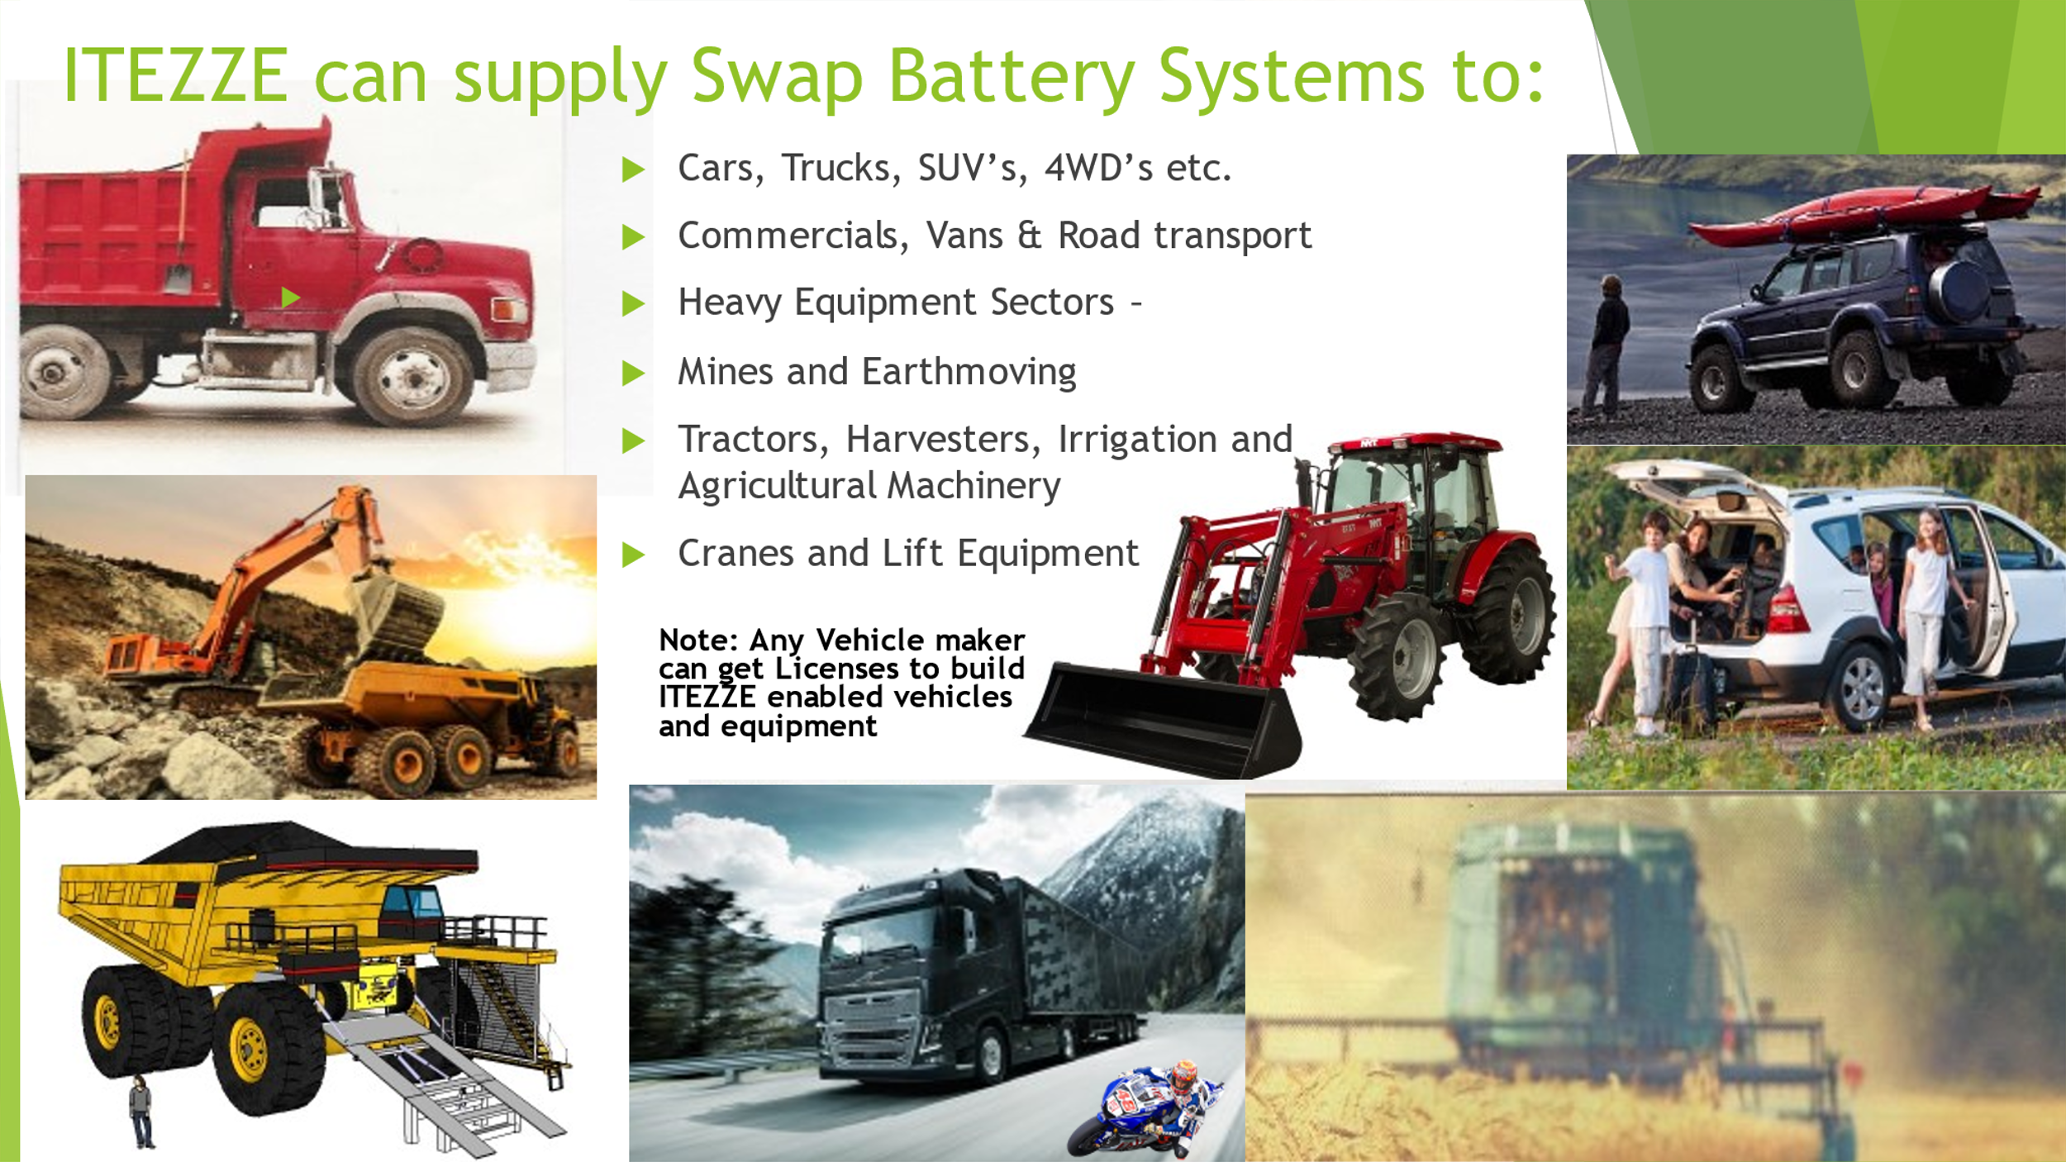
- A shortage of Residential Grid Capacity - 240-volt Residential Grids have an av. capacity of 5 KW/house;
- If too many Tesla or Nissan Leaf style cars try to home charge at once - it overloads the Residential Grid;
- Grid substations can/do explode when overloaded;
- Supercharging doesn’t work - Grids are at peak capacity from 6-8 am & 4-6pm; hence since most drivers want to use supercharge servos during peak periods - they can’t;
- ITEZZE is the only system that works for Trucks; ITEZZE means truckers can swap their PIG’s (the robotic self-propelled battery drone) every 3-5½ hours during their designated ‘rest’ stops; as the trucking industry promotes:
‘Without Trucks Australia Stops.’
ITEZZE is rolling out Globally – beginning in Australia
ITEZZE helps to solve the Problems of:
- Global Warming which ITEZZE helps to fix by reducing CO₂ & soot emissions;
- An oil supply ‘crunch’ within 3 years by replacing oil with electricity. An oil supply crunch may lead to the oil price soaring to US$300/barrel ($160 is anticipated in 2022) which would cause significant economic challenges;
- Electric Vehicle (EVs) prices being far HIGHER than people can afford - ITEZZE brings the price of EV’s down by reducing the size of resident (built-in) batteries which gives a range of 130 km for round town use and installing a swap slot for a swap battery which gives unlimited range and reduces EV prices to $17,000-$30,000.
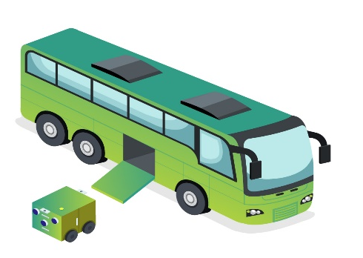
ITEZZE means councils can run their bus fleets entirely on solar
The problem of using solar when a bus operates from 4-30 am till 11 pm while the sun only shines in daytime is solved by ITEZZE. With it, solar power goes into the ITEZZE Swap Battery and the swap battery then goes into the vehicle.
It means swap batteries can recharge in sunlight while buses, cars and trucks work. Council has identified how ITEZZE can be used to run its bus fleet almost entirely on solar; using ITEZZE Mobile battery drone robots - ‘PIGs’ which swap at driver changes half way through the day. Thus, swap batteries for both the morning and evening swaps get to recharge with solar power while the bus is working. Using stationary batteries to store energy in daytime and then transferring electricity to a vehicle at night is wiped out by the cost of double handling power and volume of battery storage required in a world where there is now not enough Lithium. ITEZZE reduces bus prices by reducing the size of the resident battery which saves councils up to $400,000 per bus. It reduces battery risk (see: Technical Report) for bus makers who need to replace them. Operators hire swap batteries from an ITEZZE Licensee who provides swap batteries, electricity and recharge equipment for a battery use fee and kWh charges on power.

Thermal Runaway - Thermal runaway is where a battery may short and catch fire. Incinerating passengers is not an option. Teslas burn on the bottom of lakes. The method to deal with thermal runaway in EU is to pick up the car with a crane and drop it into a container of water (and let it burn for 3 days). Thermal runaway affects many different battery types not just Lithium. Telstra telephone exchanges have been known to burn down when their lead acid backup batteries ignited. ITEZZE uses the Triple Battery System and deals with thermal runaway in city bus fleets by making the Resident Battery a PIG so it has wheels and can be ejected and the PIG and Regeneration Battery are able to be ejected. This helps give bus customers ‘peace of mind’.

